AMERICAN ACADEMY OF PEDIATRIC DENTISTRY
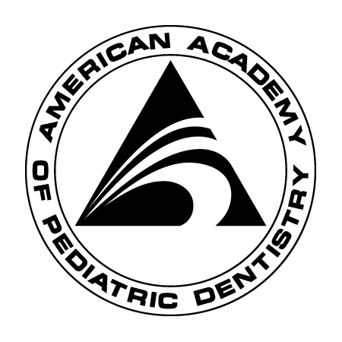
Headquarters Office 211 East Chicago Avenue – Suite 1600
Chicago, IL 60611-2663 800-544-2174 312-337-2169 Fax 312-337-6329

AAPD Pre doctoral Student Chapter Reimbursement

Please type or print clearly. Attach original receipts. Return to the Headquarters Office, Attn: Membership and Marketing Director

PAYEE INFORMATION
Name: Purpose:

Address:
Chapter:____________________________________
AAPD Pre Doctoral Student Chapters may be reimbursed up to $250 in expenses related to chapter activities.

List Expenses with receipts
1. $
2.
3.
4.
5.
6.

TOTAL AMOUNT DUE $

SIGNED: DATE:

For Headquarters Office Use Only:

Check Number: Date: 7/15

