Use of AAPD Logo
The AAPD allows the use of the AAPD logo by active and life members in good standing, as well as recognized chapters, state units and district organizations.

The logo may be used by active and life members in good standing on:
- Professional stationery
- Letterheads
- Business and referral cards and forms
- Practice promotional materials (including direct mailers to families)
- Interior and exterior doors and windows only, in AAPD member offices (limited to the member categories noted above)
- Plaques hung in offices
- Patient educational literature (so long as consistent with AAPD policies and guidelines)
- Yellow pages print and electronic advertisements (active and life members should utilize the AAPD-endorsed Yellow pages service)
- Websites

The provisions above do not allow logo use on exterior signs.

In these instances, the logo shall not be used alone, but must always be accompanied by the phrase: “Active [or Life] Member”. The logo must always be accompanied by the phrase: “AMERICA’S PEDIATRIC DENTISTS: THE BIG AUTHORITY on little teeth.”

The AAPD annually mails the logo in a sticker/decal format to each Active or Life member upon renewal of dues, facilitating display of the logo in the offices of pediatric dentists.

The size of the reproduced logo shall be reasonable and in good taste, consistent with the public image of the AAPD and the intent of this logo policy. The size must be sufficient so that the term “American Academy of Pediatric Dentistry” within the logo is clearly legible. To promote “branding” of the AAPD image to the public, the AAPD Headquarters Office will provide exact specifications. At all times, the use must comply with federal and state advertising laws and regulations. The logo shall not be altered in any way. The logo shall not be combined or incorporated into the graphic appearance of any other logo. Members may display the AAPD logo alongside other professional logos such as those indicating membership in the American Dental Association or diplomate status with the American Board of Pediatric Dentistry. However, the AAPD logo must be clearly separate and distinct from other logos. Membership in the AAPD must not be presented as implying membership in other dental associations or diplomate status.

The logo may be used under the conditions above for a partnership or group practice of pediatric dentists, but only if accompanying descriptions indicate which principal, associates, and or employee dentists in the practice are active or life members of the Academy, and which are not in these requisite member categories.

Because of the potential for confusion to the public concerning a practitioner’s specialty status, the logo may not be used by Affiliate (general dentists) or Associate (other dental specialists, physicians) members of the AAPD.

Official district and state unit organizations (i.e. chapters) must use the AAPD logo on (1) professional stationery; (2) letterhead; (3) emails; and (4) an official chapter website to advise to their members and the public that they are an official chapter of the AAPD. The AAPD logo will be available to official chapters via an .EPS, .PNG, or .JPG file depending on their needs. The logo may only be used on websites maintained by official chapters for the purpose of informing their membership about issues relating to the practice of pediatric dentistry and the activities of the official chapters and the AAPD and/or for the purpose of informing the public about the practice of pediatric dentistry. The logo may only be used once per official chapter website, either on the home page or the first page, to establish their relationship to the AAPD. No chapter shall make any abridgement or alteration of the AAPD seal or use any elements of the design of the AAPD seal in the development of their own insignia or mark. Such logo use must always be accompanied by the phrase: “[name of district] District or [name of state] chapter.” The logo must always be accompanied by the phrase: “AMERICA’S PEDIATRIC DENTISTS: THE BIG AUTHORITY on little teeth.” Two examples are provided below:

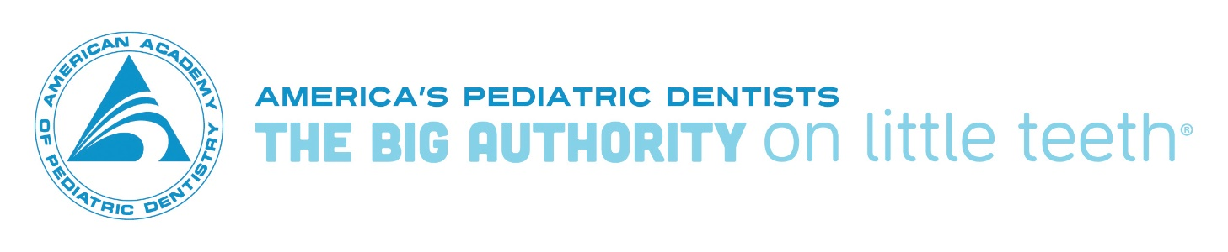
Southeastern District

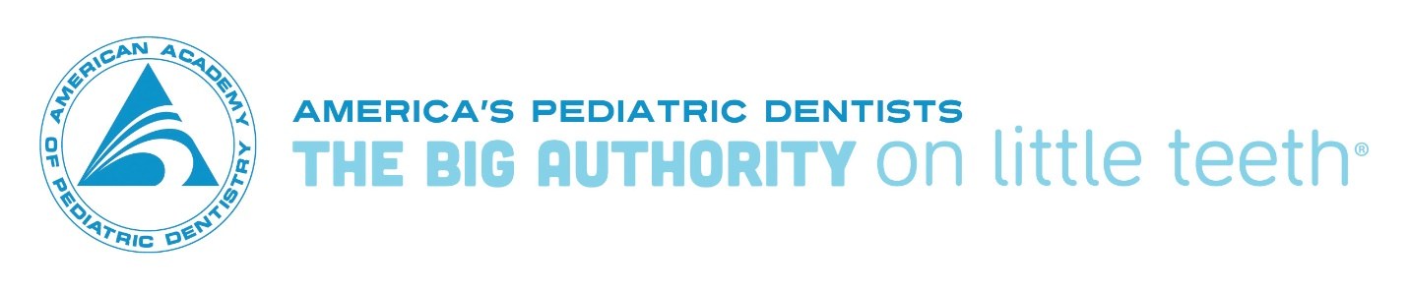
Tennessee Chapter

District and state unit organizations may utilize separate logos that indicate their specific name, provided such logos are approved by the AAPD Board of Trustees and do not conflict with the AAPD logo in terms of design and color scheme. Requests for any uses not specifically mentioned above shall be referred to the Chief Executive Officer, and considered by him or her in consultation with the Credentials and Ethics Committee.

Official predoctoral student chapters may use the AAPD logo on (1) professional stationery; (2) letterhead; (3) emails; and (4) promotional items such as tee-shirts (to be approved in advance by the AAPD). A predoctoral chapter shall not make any abridgement or alteration of the AAPD seal. Such logo use must always be accompanied by the phrase: “[Predoctoral chapter, University of X School of Dentistry].” The logo must always be accompanied by the phrase: “AMERICA’S PEDIATRIC DENTISTS: THE BIG AUTHORITY on little teeth.” An example is provided below:

Predoctoral Chapter, University of Pittsburgh School of Dentistry

