Tips from EBD: Searching for Clinical Practice Guidelines
Did you know that you can limit your search in some library databases to look for clinical practice guidelines?
In many library databases (MEDLINE, CINAHL, ClinicalKey for Nursing, Nursing Reference Center), you can limit your search to just guidelines.
Look for a filter called "guidelines", "practice guidelines", or "consensus development conference". These filters can be found under:

- Publication Types in MEDLINE and OVID (PubMed example below)
- Edit Results in CINAHL and Nursing Reference Center
- As a search type in the drop-down menu to the left of the Search Box in ClinicalKey and ClinicalKey for Nursing
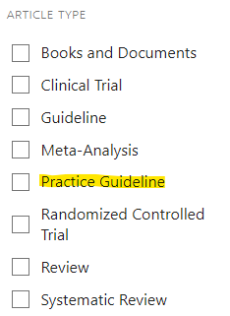
UpToDate and Dynamed clinical topics include links to pertinent guidelines in the left column on the topic pages.
Additionally, there are numerous resources available that are focused on clinical practice guidelines. For more information on where to find clinical practice guidelines, please visit the “Guidelines and Benchmarking” handout on the AAPD Evidence-Based Dentistry page.

