Little Teeth Chat (LTC) Primer

How to get to the LTC website

- For direct access, go to https://littleteethchat.aapd.org/home (this is linked, go ahead and click on it!)
- Alternatively, visit www.aapd.org, click on “My Account” at the top of the AAPD homepage, then click on “Little Teeth Chat Community.”

How to post a new discussion thread

- From the LTC Landing page, hover your indicator or mouse over “Participate” (at the top of the page), then click on “Post a Message.”
- Choose “Shared Interest Group” for the option under “Select community.”
- Select your topic, “Safety.”
- Create a title for your discussion post under “Discussion subject.”
- Insert your message in the large text box.
- Attach a document or article for further reading (these get stored in the LTC library and we can track how many people download them).
- You’re a natural!

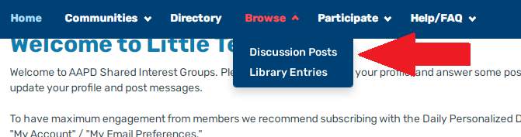

How to post on someone else’s discussion thread

- From the LTC landing page, hover your indicator or mouse over a discussion thread title and click.
- Scroll down to the last comment and click “Reply” to continue the conversation. It will be added to the bottom of the thread of comments.
- Add an attachment for further discussion.

How to set up alerts to your email

- From the LTC landing page, hover your indicator or mouse over your encircled initials in the top right corner – that’s your profile.
- Hover your indicator or mouse over “My Account” and click “Email Preferences.”
- Make sure your email preferences are “turned on” if you’d like to be notified about posts.
- Also under Account, click on “Community Notifications” and Make sure your topic notifications are set to “Personalized digest & Real-time Discussion Emails.”
