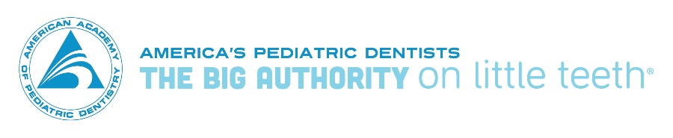

September 13, 2017

The Honorable Orrin Hatch The Honorable Ron Wyden
Chairman Ranking Member
Senate Committee on Finance Senate Committee on Finance
104 Hart Senate Office Building 221 Dirksen Senate Office Building Washington, DC 20515 Washington, DC 20515

Dear Chairman Hatch and Ranking Member Wyden,

On behalf of the American Dental Association (ADA) and its 161,000 members and the American Academy of Pediatric Dentistry (AAPD) and its 10,000 members, we applaud the Committee’s efforts to examine the future of the Children's Health Insurance Program (CHIP) at the September 7 hearing, “CHIP: The Path Forward.” The ADA and AAPD are committed to ensuring access to oral health services for all populations, especially the children and pregnant women covered by CHIP. While both of our organizations are encouraged by the announcement that bipartisan efforts to craft CHIP reauthorization legislation are in the final stages, the ADA and the AAPD urge Congress to reauthorize the CHIP program before the deadline on September 30 to ensure continued and seamless access to oral health care for our nation’s children.

More than 9 million children are covered by CHIP. As a result of their coverage, they benefit from access to oral health services. Poor oral health has serious long-term effects on an individual’s life. Tooth decay remains the most chronic condition among children and adolescents, impacting school performance and attendance. Because it is a progressive, chronic condition, a child’s oral health problems continue on into adulthood impacting employability, military readiness and overall health status.

Additionally, untreated dental disease has a significant economic impact on our healthcare system. For example, between 2008 and 2010, 4 million Americans went to the emergency room for dental-related problems at a cost of $2.7 billion dollars. In 2014, an emergency room visit for a dental condition occurred every 14 seconds in the United States, costing approximately $863 a visit compared with an average dental office visit cost of $240.

The good news: the percentage of children without dental coverage has been cut in half since 2000. As public insurance has reached greater numbers of children, the rate of untreated decay has fallen among young low-income patients; Emergency department visits for dental-related issues decreased for the first time in over 10 years, with the largest declines among children and young adults. These improvements have been driven by recent improvements to public and private oral health plans.

The ADA and AAPD support state flexibility and innovation, and yet also believe states should follow statutory guidelines when designing their CHIP benefit programs. Without such guidelines, oral health care can and may be reduced or eliminated entirely. Case in point, prior to the enactment of the Children’s Health Insurance Program Reauthorization Act of 2009, states had the ability to limit or eliminate dental benefits for enrolled children. Programs varied widely, and children suffered as a result. We urge you and your colleagues to ensure that states will not be able to limit or eliminate the dental benefits that now serve to improve the health of millions of children.

Please utilize our organizations as a resource. We look forward to working with you to ensure that our nation’s children can continue to benefit from measurable improvements in oral health care and access to dental coverage. Should you have any questions, please feel free to contact Ms. Janice E. Kupiec with the ADA, kupiecj@ada.org, or Mr. C. Scott Litch with the AAPD, slitch@aapd.org.

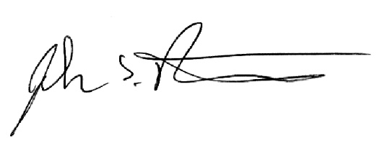
Sincerely,
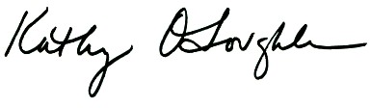

Kathleen O’Loughlin DMD, MPH John Rutkauskas DDS, MBA, CAE
Executive Director Chief Executive Officer
American Dental Association American Academy of Pediatric Dentistry

Sun BC et al. Emergency department visits for nontraumatic dental problems: A mixed-methods study. American Journal of Public health, 2015; 105(5): 947-955.
American Dental Association Health Policy Institute analysis of 2014 Truven and Nationwide Emergency Department Sample data. Accessed May 25, 2017.
Nasseh K., Vujicic M. Dental benefits coverage increase for working-age adults in 2014. Health Policy Institute Research Brief. American Dental Association. October 2016. Available: http://www.ada.org/~/media/ADA/Science%20and%20Research/HPI/Files/HPIBrief_1016_2.pdf?la=en.
Saint Louis C. Untreated dental decay is falling among children. New York Times. March 5, 2015. Available from: https://well.blogs.nytimes.com/2015/03/05/untreated-dental-decay-is-falling-among-children/?_r=0.
Wall T, Vujicic M. Emergency department visits for dental conditions fell in 2013. Health Policy Institute Research Brief. American Dental Association. February 2016. Available from: http://www.ada.org/~/media/ADA/Science%20and%20Research/HPI/Files/HPIBrief_0216_1.pdf?la=en.

