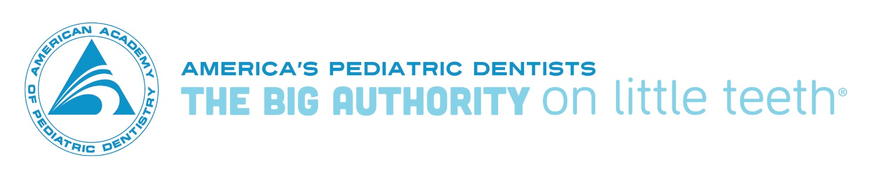
Resources for Dentists Participating in Medicaid and CHIP
- Medicaid Compliance for the Dental Professional video https://www.youtube.com/watch?v=47XrbEUTe7k&t=2998s

- Medicaid.gov
https://www.medicaid.gov/medicaid/benefits/dental/index.html

Oral Health Initiative 2.0 (OHI 2.0)
https://www.medicaid.gov/medicaid/benefits/dental/index.html
(click Children’s Oral Health Initiative)

Early, Periodic, Screening, Diagnostic and Treatment (EPSDT)
https://www.medicaid.gov/medicaid/benefits/epsdt/index.html

Innovation Accelerator Program –
Children’s Oral Health Initiative Value-Based Payment Technical Support
https://www.medicaid.gov/state-resource-center/innovation-accelerator-program/iap-functional-areas/value-based-payment/index.html

- Medicaid-Medicare-CHIP Services Dental Association (MSDA) http://www.medicaiddental.org
MSDA National Profile of State Programs
http://www.msdanationalprofile.com/

- Government Accountability Office

“Dental Services: Information on Coverage, Payments, and Fee Variation”

(GAO-13-754: Published: Sep 6, 2013. Publicly Released: Sep 12, 2013)
http://www.gao.gov/products/GAO-13-754

- Office of the Inspector General, US Department of Health and Human Services
“Questionable Billing for Medicaid Pediatric Dental Services”
California - https://oig.hhs.gov/oei/reports/oei-02-14-00480.asp
Indiana – https://oig.hhs.gov/oei/reports/oei-02-14-00250.asp
Louisiana – https://oig.hhs.gov/oei/reports/oei-02-14-00120.asp
New York - https://oig.hhs.gov/oei/reports/oei-02-12-00330.asp

“Most Children with Medicaid in Four States Are Not Receiving Required Dental Services” https://oig.hhs.gov/oei/reports/oei-02-14-00490.asp

- CA Dental Transformation Initiative
http://www.dhcs.ca.gov/provgovpart/Pages/DTI.aspx

CMS staff contacts:

CMS Chief Dental Officer Senior Policy Advisor
Lynn Douglas Mouden, DDS, MPH Laurie Norris
Lynn.mouden@cms.hhs.gov Laurie.norris@cms.hhs.gov

