QUAD A Fee Schedule
Refer to the fee charts below for your facility’s program. Fees are effective for all invoices as of July 1, 2021.
Application
Complete applications must be submitted with payment. QUAD A will not process incomplete applications or applications without payment, they will be returned to the facility for completion.
Self-Surveys and Re-Surveys
QUAD A invoices accredited facilities six months prior to their accreditation expiration date. Every third year, when the facility is due for re-survey, the facility’s invoice includes the survey fee in addition to the annual fee. The Life Safety Code also applies for Medicare-participating ASCs every third year when the facility is due for re-survey.
Facilities may initiate additional surveys during the interim period between routine surveys, such as following major renovations, changes in ownership, changes in facility class, the addition of services necessitating new major equipment, the citation of a large number or particularly serious deficiencies, or other circumstances. In such circumstances, QUAD A generates a separate invoice that the facility must pay prior to QUAD A conducting the survey.
Follow-up Surveys
QUAD A requires 100% compliance with all standards, therefore accredited facilities and applicants must be prepared for an onsite survey for the most successful process possible.
Any International, Procedural, Surgical, OMS, or Pediatric Dentistry facility that is cited a high number of deficiencies (typically 20+) or deficiencies that constitute a high level of concern by QUAD A, due to the severity or nature of the deficiencies, may require follow-up surveys to verify compliance prior to QUAD A conferring or renewing accreditation.
Any Medicare participating facility in a re-survey cycle that has condition-level deficiencies cited during the re-survey, must undergo a follow-up survey, and a second follow-up survey if condition-level deficiencies persist.
Effective for all applications or reaccreditations as of July 1, 2021, the fee for each follow-up survey will be $1,100, for a maximum of two follow-up surveys per facility allowed.

Medicare ASC facilities with Life Safety Code deficiencies which result in a condition level deficiency will incur a fee of $3,135, in order to secure an additional Life Safety Code survey to verify compliance.
Start Up Surveys
New facilities located in applicable states, must undergo a Start Up survey prior to conducting any cases, for which a one-time Start Up Survey Fee of $853 applies. States requiring accreditation in order to begin operating do not allow facilities to conduct cases until QUAD A confers accreditation. Facilities located in California, New York, Florida, Indiana, Nevada, Ohio, Texas, and Washington may require a Start Up survey. This list is not intended to be exhaustive, and the Start Up Survey Fee may apply in other states as regulations evolve.
Expedited Survey Policy (Not Applicable to Facilities in Medicare Programs)
QUAD A requires a minimum of 30 days from receipt of a completed packet of application or reaccreditation materials to schedule a survey. To be considered complete, the packet must include all associated fees, forms signed by the facility director and all staff physicians where appropriate, staff credentials, and a schedule of availability. Upon submission of the completed packet, QUAD A staff will select a survey date at least 30 days from the completion date.
Any International, Procedural, Surgical, OMS, or Pediatric Dentistry facility may request an expedited survey to be conducted within 30 days from the submission of the completed survey materials. An administrative fee of $550 applies to all expedited survey requests, as well as any additional costs incurred by QUAD A including surveyor fees, related travel expenses, and lodging costs.
Removing/Adding Physicians or FTEs
Facilities may remove or add physicians or clinical personnel by completing the appropriate staff identification form. Facilities must report changes to staff to the accreditation department within 30 days of the change, as required by the accreditation standards. Staff updates may affect the annual fee of your facility. The accounting department will adjust the annual fee and may issue an invoice or a credit per the update. Failure to report staffing changes constitutes noncompliance and requires a Plan of Correction.
Cancellation of Survey
Facilities may cancel a scheduled survey by written notice up to 31 days prior to the survey date and incur no additional charges.
Any facility that cancels a scheduled survey within 30 days of the survey date will incur cancellation charges, consisting of:

- $550 administrative fee
- Any additional costs associated with the cancellation including, but not limited to, travel and lodging and all other related expenses.
If a facility cancels a survey after the surveyor has traveled to the survey location, the cancellation fee will include:
- $550 administrative fee
- Additional survey fee
- Any additional costs for arrangements made or for extraordinary costs such as expedited service or other special fees.
Changing or rescheduling a survey date is considered a cancellation of the existing survey. The facility is responsible for all existing survey costs, consistent with the cancellation policy. The new survey date is subject to any fees that apply to the scheduling of surveys, including but not limited to expedited survey fees.
Reactivation Fee
- Facilities that lose accreditation for administrative process violations, such as non-payment, non-compliance with the survey process, or late PSDR submissions may reactivate their accreditation once by remedying the violation and paying a $500 reactivation fee within ten (10) business days of inactivation. If the reactivation request is not granted, the $500 reactivation fee will be returned. Reactivation is not applicable to Medicare accredited facilities.
- Facilities are not eligible for reactivation after a termination or denial for a failure to meet patient safety and other quality requirements; such facilities must reapply for accreditation and are subject to all routine payments and surveys in order to become accredited again.
Acceptable Forms of Payment
Make checks payable to QUAD A and submit to 7500 Grand Avenue, Suite 200, Gurnee, IL 60031. QUAD A will apply a Non-Sufficient Funds Fee (NSF) of $35 for check payments made with insufficient funds. Payment by check is not available for international facilities.
QUAD A accepts Visa, Master Card, American Express, and Discover card payments over the phone for your convenience. Call our accounting department to make your credit card payment at 888-545-5222 ext. 913 or 847-775-1970 ext. 913.
QUAD A also accepts wire transfers. For wire transfer instructions call 888-545-5222 ext. 923 or 847-775-1970 ext. 923 or email accounting@QuadA.org.

Payment Terms
QUAD A billing terms are 30 days. Overdue invoices incur late fees every 30 days beyond the invoice due date; other penalties also follow and may result in the termination of accreditation. QUAD A will only proceed with reaccreditation processes after receiving payment for any outstanding invoices and is not responsible for any gaps in accreditation caused by nonpayment of invoiced fees.
Refund Policy
If a facility withdraws its application or renewal request, an inactivation form must be completed and signed by the facility’s director or another responsible party, if the director of the facility is no longer reachable. The signed form must include documents that are relevant to the inactivation request, QUAD A may require additional information depending on the circumstances. QUAD A will refund 50% of the annual fee and 100% of the survey fee, provided the application or renewal packet has been submitted and processed but the facility has not been surveyed. If QUAD A already performed the survey, QUAD A will only refund 50% of the annual fee and none of the survey fee. A $100 administrative fee will be subtracted from each refund. If the facility does not complete the accreditation process within one year of the date QUAD A received the application, the application is considered expired, and the facility must submit a new application and appropriate fees to become accredited. Expired applications, facilities that have received their certificate, or facilities with revoked accreditation are not eligible for refunds.

Annual Fees for Accreditation – Non-Medicare Programs
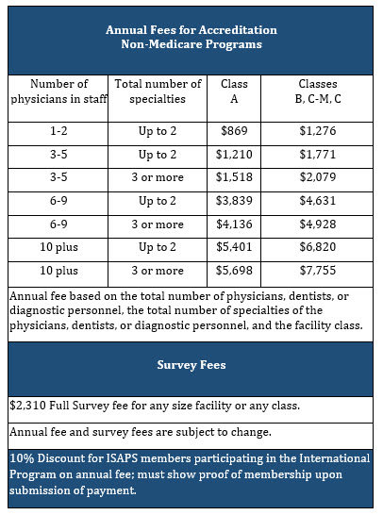

Annual Fees for Pediatric Dentistry Accreditation

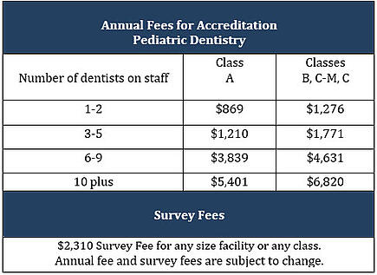

Annual Fees for Medicare Surgical (ASC) Accreditation
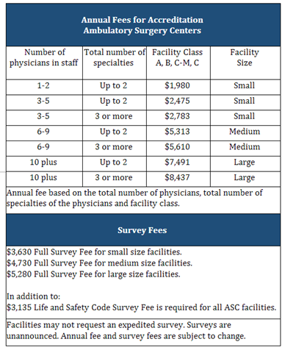

Annual Fee for OPT Accreditation
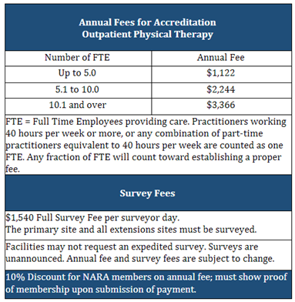

Annual Fee for RHC Accreditation
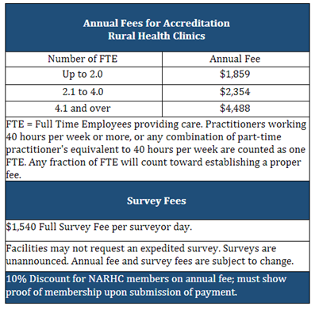

Annual Fee for International Accreditation
