American Academy of Pediatric Dentistry
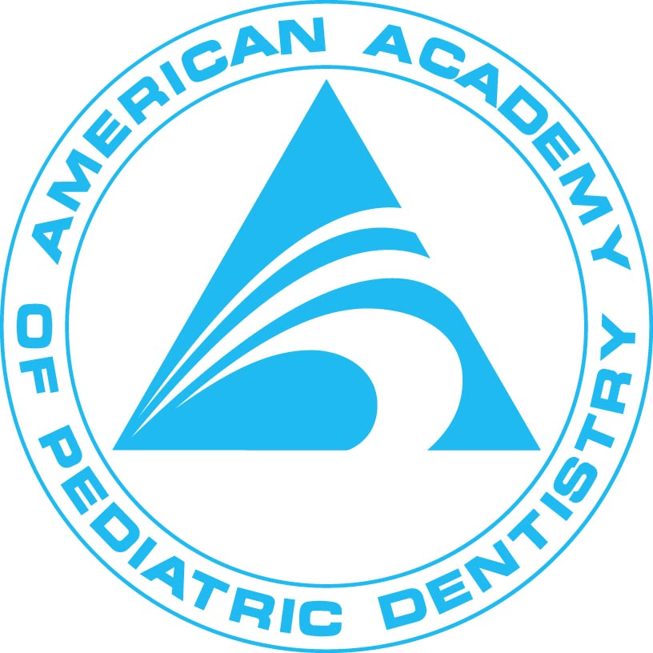
2011 AAPD Congressional Lobby Days

“Team leaders” (in red) are indicated for all state delegations with more than two attendees; this person will be the main point of contact for scheduling visits and reporting confirmed visits back to Margaret Bjerklie at the AAPD HQ.

Alabama
Dr. Charles Hall
AAPD PAC Advisory Board
2918 Eastern Shore Dr SE
Hampton Cove, AL 35763-9339
drcharleshall@bellsouth.net

Arizona
Dr. Jessica Robertson
1110 W Beal Rd
Flagstaff, AZ 86001-1281
ohsudent@yahoo.com

Dr. Sally Tor
Resident, The Ohio State University Nationwide Children’s Hospital
139 E Main St Apt 400
Columbus, OH 43215-5432
sally.tor@gmail.com

California
Dr. Francesca Artiga
Resident, UCLA
8110 Birmingham Way Bldg 28
San Diego, CA 92123-2758
francescadds@gmail.com

Dr. Magnolia Becker
Resident, UCLA
1440 23rd St Apt 210
Santa Monica, CA 90404-2948
magnolia.becker@gmail.com

Dr. James J. Crall
AAPD Council on Government Affairs
12540 Braddock Dr Apt 216B
Los Angeles, CA 90066-6876
jcrall@dentistry.ucla.edu

Dr. Alison Fronczak
Resident, UCLA
8685 Rio San Diego Dr Apt 4145
San Diego, CA 92108-6554
alison.fronczak@gmail.com

Dr. Mark Lisagor
AAPD PAC Advisory Board
477 Calle Higuera
Camarillo, CA 93010-1812
marklisagor@gmail.com

Dr. Carrie Loewen
Resident, UCLA
12021 Wilshire Blvd # 804
Los Angeles, CA 90025-1206
clloewen@gmail.com

Dr. Gerardo Martinez
Resident, UCLA
1417 S Beverly Glen Blvd
Los Angeles, CA 90024-7707
gmartt@ucla.edu

Dr. Breanne Reid
Resident, UCLA
5088 Plaza Promenade
San Diego, CA 92123-6452
pedo2bee@gmail.com

Dr. Brian Rooney
Resident, UCLA
1257 12th St Apt 17
Santa Monica, CA 90401-2081
bjr264@gmail.com

Dr. Deyanira Sanchez
Resident, UCLA
4246 Saltillo St
Woodland Hills, CA 91364-5929
deyasanchez@ucla.edu

Dr. Ray E. Stewart (TEAM LEADER)
AAPD PAC Steering Committee, District 6 Representative
PO Box 222827
Carmel, CA 93922-2827
drrstewart@aol.com

Colorado
Dr. Jeffrey Kahl
9480 Briar Village Pt Ste 301
Colorado Springs, CO 80920-7923
kahlja@msn.com

Dr. Sean Whalen
5150 W 80th Ave
Westminster, CO 80030-4449
seanwhalendds@yahoo.com

Connecticut
Dr. Scott Bialik
246 Federal Rd Ste D13
Brookfield, CT 06804-2649
drbialik@drbialik.com

Dr. Douglas Keck
AAPD Council on Government Affairs
62 Denison Dr
Guilford, CT 06437-2344
dougkeck@earthlink.net

Georgia
Dr. Rhea Haugseth (TEAM LEADER)
AAPD President-Elect
2155 Post Oak Tritt Rd Ste 450
Marietta, GA 30062-8608
rheadmd@bellsouth.net

Dr. Miles Mazzawi
AAPD Council on Government Affairs
205 Waleska Rd Ste 2B
Canton, GA 30114-2493
yards42@yahoo.com

Dr. J.C. Shirley
290 Powers Pl NE
Marietta, GA 30067-4086
jcshirley@aol.com

Dr. Monica Patel
Resident, The Ohio State University Nationwide Children’s Hospital
317 Frankfort Sq
Columbus, OH 43206-1061

Dr. Anjali Williamson
Resident, Children’s National Medical Center
1301 20th St NW Apt 313
Washington, DC 20036-6032
anjalilunia@hotmail.com

Illinois
Dr. Charles Czerepak
1460 N Halsted St # 403
Chicago, IL 60642-2605
pinedent@aol.com

Mr. C. Scott Litch
AAPD Chief Operating Officer and General Counsel
211 E Chicago Ave # 1700
Chicago, IL 60611-2637
slitch@aapd.org

Dr. John Rutkauskas
AAPD Chief Executive Officer
211 E Chicago Ave # 1700
Chicago, IL 60611-2637
jrutkauskas@aapd.org

Dr. Neophytos Savide (TEAM LEADER)
AAPD PAC Steering Committee, District 4 Representative
12001 S Harlem Ave
Palos Heights, IL 60463-1139
nlsavide@aol.com

Indiana
Dr. James Jones
James Whitcomb Riley Hospital
702 Barnhill Dr # 4205
Indianapolis, IN 46202-5128
jej7@iupui.edu

Kansas
Dr. John Fales, Jr.
13496 S Arapaho Dr
Olathe, KS 66062-1553
jtf@kidzdentist.com

Kentucky
Dr. Thomas Ison
AAPD Board of Trustees, District 3 Trustee/AAPD PAC Steering Committee
9710 Park Plaza Ave Unit 101
Louisville, KY 40241-2292
tison@pediatricdentalgrouplouisville.com

Dr. Beverly Largent
AAPD Council on Government Affairs/Past President
3008 Oregon St
Paducah, KY 42001-5651
drlargent@comcast.net

Louisiana
Dr. Robert Delarosa
AAPD Board of Trustees, District 5 Trustee/Budget and Finance Committee
9000 Airline Hwy Ste 100
Baton Rouge, LA 70815-4183
robertdelarosa@mac.com

Dr. John Hendry
AAPD PAC Steering Committee/Board of Trustees, At-Large Trustee-Elect
185 S Beadle Rd
Lafayette, LA 70508-4287
drjohn@drjohnhendry.com

Maine
Dr. Stephen C. Mills
300 Technology Way
Scarborough, ME 04074-7654
LMILLS5977@aol.com

Maryland
Dr. Warren Brill (TEAM LEADER)
AAPD Secretary-Treasurer
1001 N Point Blvd
Baltimore, MD 21224-3413
drwbrill@comcast.net

Dr. Roselyne Gichana
Resident, Children’s National Medical Center
6105 Madawaska Rd
Bethesda, MD 20816-3110
rgichana@cnmc.org

Dr. Kristen Maloney
Resident, Children’s National Medical Center
608 S Linwood Ave
Baltimore, MD 21224-3827
maloney.kristen@gmail.com

Dr. Deven V. Shroff
10045 Baltimore National Pike Ste A1
Ellicott City, MD 21042-3673
seesmiles@gmail.com

Dr. Anupama Tate
5300 Carlton St
Bethesda, MD 20816-2304
atate@cnmc.org

Dr. Hilary Sherman Weiss
Children's National Medical Center
Washington, DC 20010-2916
hsweiss@cnmc.org

Dr. Patrice Wunsch
AAPD Council on Government Affairs
1576 Penzance Way
Hanover, MD 21076-1480
pbwunsch@me.com

Minnesota
Dr. James Nickman
AAPD Board of Trustees, District 4 Trustee/Council on Government Affairs
700 Village Center Dr
North Oaks, MN 55127-3019
james.nickman@att.net

Mississippi
Dr. Heber Simmons, Jr.
AAPD Congressional Liaison
1855 Crane Ridge Dr
Jackson, MS 39216-4944
hebersimmonsjr@aol.com

Missouri
Dr. John Bogert
AAPD PAC Advisory Committee
1011 E Turnbridge Cir
Springfield, MO 65810-2868
jabogert1101@att.net

Dr. Kecia Leary
609 N Jerico St
Nixa, MO 65714-8963
kleary@jvchc.com

Montana
Dr. Jane Gillette
AAPD Board of Trustees, Affiliate Trustee-Elect
40 E Mendenhall St
Bozeman, MT 59715-3631
drgillette@refreshingdentistry.com

Nebraska
Dr. Jessica Meeske
AAPD PAC Advisory Committee/Council on Government Affairs
601 N Saint Joseph Ave
Hastings, NE 68901-7531
jmeeske@windstream.net

New Jersey
Dr. Cavan Brunsden
AAPD PAC Steering Committee, District 2 Representative
2455 Highway 516
Old Bridge, NJ 08857-1892
brunsden@kidzdent.com

Dr. Maria Cordero
Resident, The Ohio State University Nationwide Children’s Hospital
687 N High St Apt 3H
Apt 3H
Columbus, OH 43215-1591
corderodmd@gmail.com

Dr. Jennifer Cully
41 Hearthstone Ln
Marlton, NJ 08053-5366
drjennifercully@gmail.com

Dr. Lewis Kay (TEAM LEADER)
AAPD PAC Steering Committee Chair
401 Mallard Ln
Moorestown, NJ 08057-4304
lewjo58@comcast.net

Dr. Madeline Monaco
210 Tabor Rd
Morris Plains, NJ 07950-2613
mmonaco@its.jnj.com

New York
Dr. Lois Jackson
AAPD PAC Advisory Board
505 Laguardia Pl Suite L4
New York, NY 10012-0045
lajnyc@aol.com

Dr. Bhagwati Mistry
11 Beech Ln
Tarrytown, NY 10591-3001
bjmistry@optonline.net

Dr. Lisa Newman
Resident, The Ohio State University Nationwide Children’s Hospital
317 Frankfort Sq
Columbus, OH 43206-1061
newman.436@osu.edu

Dr. Reneida Reyes (TEAM LEADER)
AAPD PAC Steering Committee, District 1 Representative
1 Hanson Pl Ste 706
Brooklyn, NY 11243-2907
lilteethreyes@gmail.com

North Carolina
Dr. Scott Cashion (TEAM LEADER)
AAPD Board of Trustees Trustee at Large/ Budget and Finance Committee/Council on Government Affairs
402 Turnstone Trl
Greensboro, NC 27455-1370
scashion@me.com

Dr. Jacqueline Hom
Resident, University of North Carolina
228 Braver Hall Cb#7450
Chapel Hill, NC 27599-0001
jhom@dentistry.unc.edu

Dr. Jasper Lewis, Jr.
AAPD PAC Advisory Board
1025 Johns Hopkins Dr
Greenville, NC 27834-7227
jasperlewisjrdds@eopd.org

Ohio
Dr. Homa Amini (TEAM LEADER)
700 Childrens Dr
Columbus, OH 43205-2664
Homa.Amini@nationwidechildrens.org

Dr. Amanda Gaynor Ashley (will be making visits to Alaska delegation)
Resident, The Ohio State University Nationwide Children’s Hospital
85 Park Front Ct
Columbus, OH 43215-4155
agaynor100@hotmail.com

Dr. Paul Casamassimo
700 Childrens Dr
Columbus, OH 43205-2664
casamassimo.1@osu.edu

Dr. Carolyn Crowell
36855 American Way Ste C
Avon, OH 44011-4059
carolyncrowell@oh.rr.com

Dr. Joseph Jackson
Resident, The Ohio State University Nationwide Children’s Hospital
555 S 18th St
Columbus, OH 43205-2654
jackson.joe@gmail.com

Dr. Kara Morris
AAPD Council on Government Affairs
301 Siebert St
Columbus, OH 43206-2775
karaschafer@yahoo.com

Pennsylvania
Dr. Brian Martin
AAPD Council on Government Affairs
116 Shannon Dr
Blawnox, PA 15238-1714
martbs@chp.edu

Dr. Elliott Maser (TEAM LEADER)
AAPD PAC Advisory Board
3101 Bristol Rd Ste 1
Bensalem, PA 19020-2168
Edmaser1@cs.com

Dr. Jessie McQuiston
Resident, The Ohio State University Nationwide Children’s Hospital
397 Stewart Ave
Columbus, OH 43206-2729
jessmcq@hotmail.com

Dr. Priyanka Vaddi
Resident, Children’s National Medical Center
3039 Macomb St NW Apt 31
Washington, DC 20008-3322
pri.vaddi@gmail.com

Rhode Island
Dr. Daniel Kane
21 Peace St
Providence, RI 02907-1510
dkane@saintjosephri.com

South Carolina
Dr. Isabel and Mr. Jacob Driggers
1000 Tanner Ford Blvd Ste 370
Hanahan, SC 29410-4712
isabeldriggers@gmail.com

Dr. Meredith Papadea
PO Box 3595
Pawleys Island, SC 29585-3595
meredithpapadea@aol.com

South Dakota
Dr. Melvin Thaler
2502 S Big Timber Pl
Sioux Falls, SD 57105-5159
melthaler@yahoo.com

Tennessee
Dr. K. Jean Beauchamp
AAPD Board of Trustees, Parliamentarian, District 3 Trustee-Elect, AAPD PAC Assistant Treasurer
2297 Rudolphtown Rd
Clarksville, TN 37043-2226
kjbscott@aol.com

Dr. Edward H. Moody, Jr.
AAPD Secretary-Treasurer nominee
920 W. Main St.
Morristown, TN 37814-4515
emoody@charter.net

Texas
Dr. Philip Hunke
505 E Newport Ln
McAllen, TX 78501-1146
philhunke@aol.com

Dr. Carolyn Kerins
PO Box 190556
Dallas, TX 75219-0556
ckerins@bcd.tamhsc.edu

Dr. Jason F. Koesters
5052 Crawford Dr
The Colony, TX 75056-1614
jkoesters@bcd.tamhsc.edu

Dr. Rachael A. Revell
2707 Cole Ave
Dallas, TX 75204-1006
rachael.a.revell@gmail.com

Vermont
Dr. George Richardson
AAPD PAC Advisory Board
PO Box 116 2757 Greenbush Road
Charlotte, VT 05445-0116
spindoc207@aol.com

Virginia
Dr. Elizabeth Berry
7635 Patriots Landing Pl
Quinton, VA 23141-1643
clarkej2@vcu.edu

Dr. Tegwyn Brickhouse
PO Box 980566 521 N 11th Street, Room 305
Richmond, VA 23298-0566
thbrickhouse@vcu.edu

Dr. James Keeton, Jr. (TEAM LEADER)
AAPD Council on Government Affairs
Manchester Dental Building
7410 Hull Street Rd Ste 1
Richmond, VA 23235-5834
jamesmkeeton@aol.com

Washington
Dr. Kyoko Awamura
875 140th Ave NE Ste 200
Bellevue, WA 98005-3400
skimort3@msn.com

Dr. Joel Berg (TEAM LEADER)
AAPD Vice President
Center For Pediatric Dentistry
6222 NE 74th St
Seattle, WA 98115-8158
joelberg@uw.edu

Dr. John Liu
AAPD President
185 NE Gilman Blvd
Issaquah, WA 98027-2937
drliu@eastsidepediatricdental.com

West Virginia
Dr. Elliot Shulman
43 Garden Ln
Morgantown, WV 26501-2291
penguin1st@comcast.net

