SMG Directory Marketing Introduces Internet Advertising for AAPD Members

Reach patients who are searching online!
SMG Directory Marketing is your agency authorized to manage your print and online yellow pages. Many of you have been placing yellow pages ads with us for several years. Now you can advertise with us online, too. Internet Yellow Pages (IYPs) and Local Search are powerful tools that connect you with customers who are searching online and ready to call.

Internet Yellow Pages (IYPs)
Internet Yellow Pages (IYPs) serve as an online extension of traditional yellow pages and are assuming a dominant role in the growing and increasingly popular “local search” arena.
- According to industry researcher comScore MediaMetrix, 1 out of every 4 Internet users utilizes IYPs as a part of their buying process.
- Similar to the print version, IYPs are used by individuals who are at an important point in their decision-making process.
- 67% of IYP users make or intend to make a purchase at the time of use.
- Importantly, IYPs not only deliver online traffic to a web site, but also provide potential customers with a phone number and contact information.

Sample IYP Ad

SMG offers programs on the following IYP sites:
  - Yellowpages.com
    - Affiliated with the following sites: AOL Yellow Pages, AnyWho, Yahoo! Yellow Pages, Yahoo! Local, 411.com, Areaguides.net, Addresses.com
  - Superpages.com
    - Affiliated with the following sites: Google, Yahoo!, Switchboard, About.com, Local.com, 411 Info, WhitePages.com, America 411, MojoPages, CitySearch, InfoUSA, ZipCodez, Lycos, BigFoot, Info Space, HotBot
  - Dexknows.com
    - Affiliated with the following sites: Google, Yahoo! Local, Live Search,Local.com, Welcome Wagon, InsiderPages, Realtor.com, Addresses.com
  - YellowBook.com
    - Affiliated with the following sites: Google, Yahoo, WebReach Search Engine Marketing
  - CitySearch.com
    - Affiliated with the following sites: AOL, MSN, Ask City, Insider Pages, Match.com, Mapquest, Excite, Local.com, Merchant Circle, Adelphia, WeatherBug, Magic Yellow, Marchex, YellowBot, Superpages.com, FlightView, 1800-Free-411, Charter

IYP Prices
The annual prices of the IYP listings generally range from approximately $480 to $1,200 per year, depending on the IYP site and your local market. The annual price includes placement of your listing under 3-5 categories, depending on the site. This allows you to market yourself under Dentists, Pediatric Dentists, Dental Clinics or other relevant categories for one low price.

The links will go directly to your website. If you want to place an IYP but do not have a website, we can create a customized landing page that is like a mini website for only $235 more annually.

Sample Traffic

YellowPages.com | Traffic- Last 12 Months
Dental Clinics | 1,299,811
Dental Hygienists | 28,146
Dentists | 4,320,338
Dentists-Cosmetic Dentistry | 391,983
Dentists-Oral & Maxillofacial Surgery | 895,926
Dentists-Pediatric Dentistry | 760,257
Physicians & Surgeons, Oral Surgery | 425,305
Total: | 8,121,766
SuperPages.com | Traffic- Last 12 Months
Cosmetic Dentists | 76,635
Dental Clinics | 256,904
Dental Hygienists | 18,638
Dentists | 4,537,789
Oral & Maxillofacial Pathology & Surgery Dentists | 81,772
Pediatrics Dentists | 155,384
Total: | 5,127,122
Citysearch.com | Traffic- April 2008
Medical Specialists- Dentists | 14,147,277
Total: | 14,147,277

Local Search Program
SMG Directory Marketing now offers a customized Local Search program tailored to your specific market’s needs. We review keywords most frequently searched online by local customers in your market, and determine relevant coverage and marketing spend levels.

Examples of local keywords: Dentist, Pediatric Dentist, Dallas TX, Pediatric, Children’s Dentist, Dallas, TX, etc.

This includes placement of specific keywords near the top of local search results on major search engines such as Google, Yahoo! and MSN.

Sample of Search Result Page

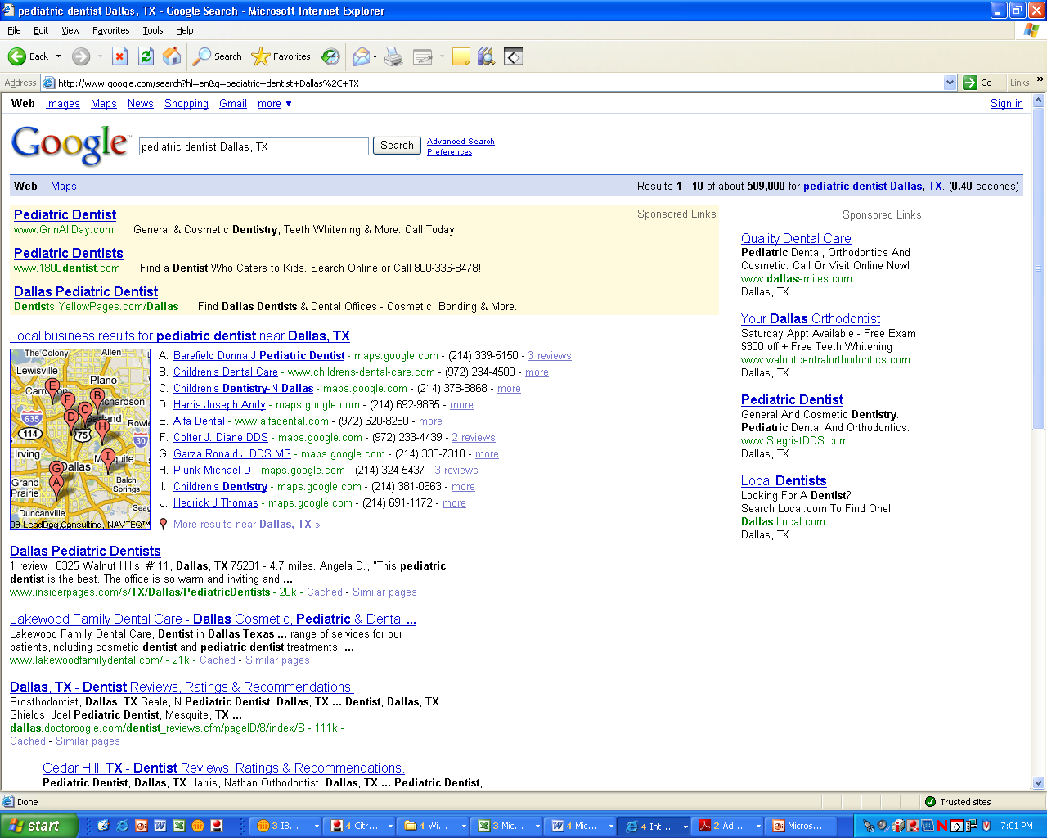

Reporting
Through SMG’s online tools you will have 24/7 access to real-time campaign data. You will be able to see how many phone calls are generated through your campaign and how many emails or lead inquires are driven by the program.

Contact Us
Online advertising can be purchased at any time during the year and is quickly activated to provide measurable results.

Call us at 800-333-1100 ext. 6823 or email christina.janiczek@smgdm.com. Christina can assist you with your yellow pages needs, both in print and online.

