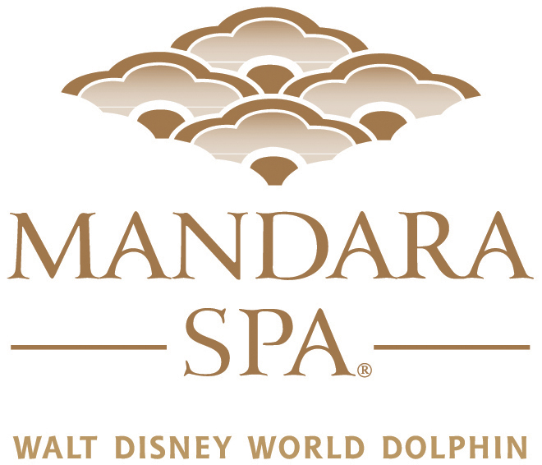

Mandara Spa would like to welcome American Academy of Pediatric Dentistry to the Walt Disney World Swan and Dolphin Hotel, and wish you a wonderful and relaxing stay!

Currently Mandara Spa is offering some wonderful specials exclusively for your group. You will save $20.00 on any individual service valued at $100.00 or more! In addition, we will also be extending a 20% discount on all retail purchases for your group while you are with us.

Both Service and Retail discounts are not to be used in conjunction with any other offers, discounts or packages.

To take advantage of this special offer, and experience one of our luxurious treatments, please mention this letter and your group when making your reservation. We also ask that you please present this letter to the spa concierge when you check in for your appointment.

We do request that you check in 15 minutes before your treatment. For your convenience, a 20% gratuity is automatically added to all treatments.

Mandara Spa is located on the lobby level at the Dolphin by the East Elevators. We are open daily from 8am to 9pm. For appointments please call extension 4772 from any house phone, or (407) 934-4772 from an outside line to secure your reservations.

Best regards,

The Staff of Mandara Spa

